Revision for Grade11- Unit test-1
- With the help of truth table prove that 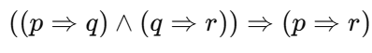 is tautology.
- State and prove Involution law
- Identify the law A+BC = (A+B)(A+C) and Write the duality for the same.
- What are universal gates. Why they are called as Universal gates
- Draw XNOR gate and write the expression for the same
- Draw AND gate using NAND gate
- Draw circuit for the (A’ +B).(A.C).(B + C)
- Write converse , inverse and contrapositive for
(i)If it is January, then it is cold. (Ii) (ii) If y +5 ≠7, then y
9. If s stands for the statement "I will not go to school", and t for the statement, "I will watch a movie", then what does ~s + t stand for?
10. Subtract 100001 - 111 using 2’s complement

